Project Initialization and Planning Phase

Date | 20 February 2026
Team ID | LTVIP2026TMIDS28544
Project Name | Gemini Historical Artifact
Maximum Marks | 3 Marks

Define Problem Statements:
Historians and students often struggle to analyse and document historical artifacts because manual research is time-consuming and requires extensive knowledge, while online resources provide only generic information. The Artifact AI application addresses this issue by using AI to quickly generate accurate, structured, and context-aware descriptions based on user input, making artifact analysis faster and more efficient.

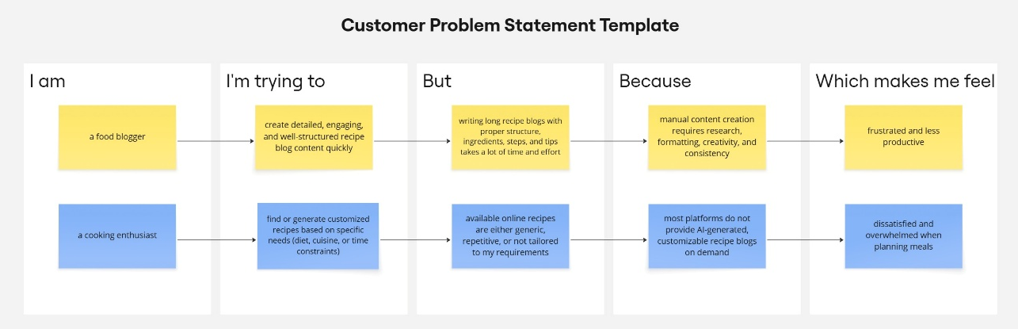

PS | I am | I’m trying to | But | Because | Which makes me feel
PS-1 | A history student | Complete assignments on historical artifacts | Research takes too much time | Requires reading and organizing info | Stressed and slow
PS-2 | A museum curator | Prepare artifact descriptions | Content writing is repetitive | Needs structured accurate data | Frustrated

